Select the correct description of right-hand and left-hand behavior of the graph of the polynomial function.
ƒ(x) = 4x² - 5x + 4
Falls to the left, rises to the right.
Falls to the left, falls to the right.
Rises to the left, rises to the right.
Rises to the left, falls to the right.
Falls to the left.

QUESTION 2
Describe the right-hand and the left-hand behavior of the graph of
t(x) = 4x⁵ - 7x³ - 13
Because the degree is odd and the leading coefficient is positive, the graph falls to the left and rises to the right.
Because the degree is odd and the leading coefficient is positive, the graph rises to the left and rises to the right.
Because the degree is odd and the leading coefficient is positive, the graph falls to the left and falls to the right.
Because the degree is odd and the leading coefficient is positive, the graph rises to the left and falls to the right.
Because the degree is even and the leading coefficient is positive, the graph rises to the left and rises to the right.

QUESTION 3
Select the correct description of right-hand and left-hand behavior of the graph of the polynomial function.
ƒ(x) = 3 - 5x + 3x² - 5x³
Falls to the left, rises to the right.
Falls to the left, falls to the right.
Rises to the left, rises to the right.
Rises to the left, falls to the right.
Falls to the left.

QUESTION 4
Select from the following which is the polynomial function that has the given zeroes.
2,-6
f(x) = x² - 4x + 12
f(x) = x² + 4x + 12
f(x) = -x² -4x - 12
f(x) = -x² + 4x - 12
f(x) = x² + 4x - 12

QUESTION 5
Select from the following which is the polynomial function that has the given zeroes.
0,-2,-4
f(x) = -x³ + 6x² + 8x
f(x) = x³ - 6x² + 8x
f(x) = x³ + 6x² + 8x
f(x) = x³ - 6x² - 8x
f(x) = x³ + 6x² - 8x

QUESTION 6
Sketch the graph of the function by finding the zeroes of the polynomial.
f(x) = 2x³ - 10x² + 12x
0,2,3
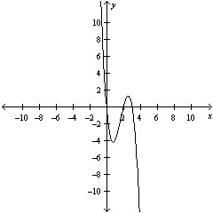
0,2,-3
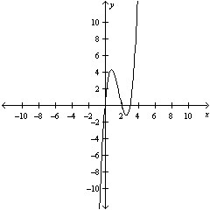
0,-2,3
0,2,3
0,-2,-3

QUESTION 7
Select the graph of the function and determine the zeroes of the polynomial.
f(x) = x²(x-6)
0,6,-6
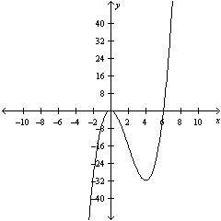
0,6
0,-6
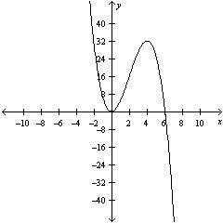
0,6
0,-6

QUESTION 8
Use the Remainder Theorem and Synthetic Division to find the function value.
g(x) = 3x⁶ + 3x⁴ - 3x² + 6, g(0)
6
3
-3
8
7

QUESTION 9
Use the Remainder Theorem and Synthetic Division to find the function value.
f(x) = 3x³ - 7x + 3, f(5)
-343
343
345
340
344

QUESTION 10
Use the Remainder Theorem and Synthetic Division to find the function value.
h(x) = x³ - 4x² - 9x + 7, h(4)
-28
-27
-31
-25
-29

QUESTION 11
Use synthetic division to divide:
(3x³ - 24x² + 45x - 54) ÷ (x-6)
6x² - 3x - 9, x ≠ 6
6x² -3x - 9, x ≠ 6
3x² - 6x + 9, x ≠ 6
3x² - 6x - 9, x ≠ 6
3x² + 6x + 9, x ≠ 6

QUESTION 12
Use synthetic division to divide:
(x³ - 27x + 54) ÷ (x - 3)
x² + 3x - 18, x ≠ 3
x² - 3x - 27, x ≠ 3
x² + 9x + 18, x ≠ 3
x² + 9x - 6, x ≠ 3
x² + 6x + 9, x ≠ 3

QUESTION 13
Use synthetic division to divide:
(4x³ - 9x + 16x² - 36) ÷ (x + 4)
4x² - 9, x ≠ -4
4x² + 9, x ≠ -4
-4x² - 9, x ≠ -4
4x³ - 9, x ≠ -4
4x³ + 9, x ≠ -4

QUESTION 14
Use synthetic division to divide:
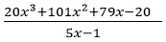
5x² + 45x + 25, x ≠ ¹/₅
16x² + 80x + 20, x ≠ ¹/₅
100x² + 45x + 400, x ≠ ¹/₅
20x² + 180x + 400, x ≠ ¹/₅
4x² + 21x + 20, x ≠ ¹/₅

QUESTION 15
Find all of the zeroes of the function.
(x - 3)(x + 9)³
-3,9
3,9
-3,-9
-3,3,9
3,-9

QUESTION 16
Find all the rational zeroes of the function.
x³ - 12x² + 41x - 42
-2, -3, -7
2, 3, 7
2, -3, 7
-2, 3, 7
-2, 3, -7

QUESTION 17
Determine all real zeroes of f.
f(x) = x³ + x² - 25x - 25
-5,1,0
5,0,-5
-5,-1,5
-5,0,0
5,-1,0

QUESTION 18
The height, h(x), of a punted rugby ball is given by 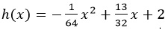 where x is the horizontal distance in feet from the point where the ball is punted. How far, horizontally, is the ball from the kicker when it is at its highest point?
28 feet
13 feet
18 feet
23 feet
16 feet

QUESTION 19
The profit P (in hundreds of dollars) that a company makes depends on the amount x (in hundreds of dollars) the company spends on advertising according to the model.
P(x) = 230 + 40x - 0.5x²
What expenditure for advertising will yield a maximum profit?
40
0.5
230
20
115

QUESTION 20
The total revenue R earned per day (in dollars) from a pet-sitting service is given by
R(p) = -10p² + 130p
where p is the price charged per pet (in dollars).
Find the price that will yield a maximum revenue.
$7.5
$6.5
$8.5
$9.5
$10.5

